Gamer Rank Directory

Aim: -
The aim of this experiment is to create a directory containing gamer id’s of players and their respective rank.

Research: -
In today’s world, the entertainment industry is highly valued and is constantly expanding.
In this, the gaming industry has seen the biggest increase in value and demand.
People across a world use gaming as a tool for relaxing or even as a tool to make money via streaming their gameplay on platforms like Twitch.
Thus, to categorize players according to their skills, tiers or levels are required.
These ranks help in matchmaking and ranking systems, ensuring players face opponents of similar skill level.
They are used to evaluate strength and viability of different characters, builds or strategies within the game.
Ranks help gamers to recognize their skills and strive for higher ranks, building a competitive gaming community which essentially is the factor that accelerates the growth of the game.
References: -
1. What is Elo? Understanding how rankings work in gaming | esports.gg
2. How does the rating system work? - Game Voyage

Analysis: -
Ranks are one of the most important systems in the game.
Generally, winning or losing a match is the most important factor in determining one’s rank.
However, other factors such as individual performances are also considered in order to ensure fairness.
Other factors in determining rank include:
Mechanical Skill: Reaction time, aim, APM (actions per minute) – increase as the rank increases.
Game Sense/Tactical Awareness: Understanding game mechanics and using them in gameplay will lead to an increase in rank.
Adaptability: Players are required to adjust to unexpected situations, counter-strategies, and enemy compositions on the fly. This increases as the rank increases.
Decision Making Under Pressure: Clutch plays, calm thinking in high-stakes moments – ability to do this is crucial in rank determination.
Consistency: Consistent performance is crucial to climb the rankings.
Ideate: -
In this code, we store the gamer id’s and their respective rank in the directory using array of strings.
Then we take input from user for gamer id, then using strcmp function to compare the strings.
If they are found to be equal, then it prints the rank according to the gamer tag.
If they are not equal, the program displays the message
“Name not present in directory”

Build: -
#include<stdio.h>
#include<string.h>

int main()
{
char gamer_id[10][80]={"Aditya_Chikhalikar","Sarthak_Chawake","Ravin_Godbole","Abhay_Dubey","Rajveer_NaikNimbalkar","Apurva_Tulpuley","Aadi_Shah","Prathamesh_Patil","Abhishek_Bhonde","Atharva_Chandorkar"};
char rank[10][80]={"God","Legendary","Master","Platinum","Diamond","Gold","Silver","Bronze","Iron","Copper"};
char entry[80];
int i,n;
int res=0;

printf("Enter name: ");
scanf("%s", entry);

for(i=0;i<10;i++)
{
if(strcmp(entry,gamer_id[i])==0)
{
printf("Name Found\n");
printf("Rank is %s", rank[i]);
res++;
break;
}
}

if(res==0)
{
printf("Name not present in directory");
}
}

Testing: -
Case 1: -
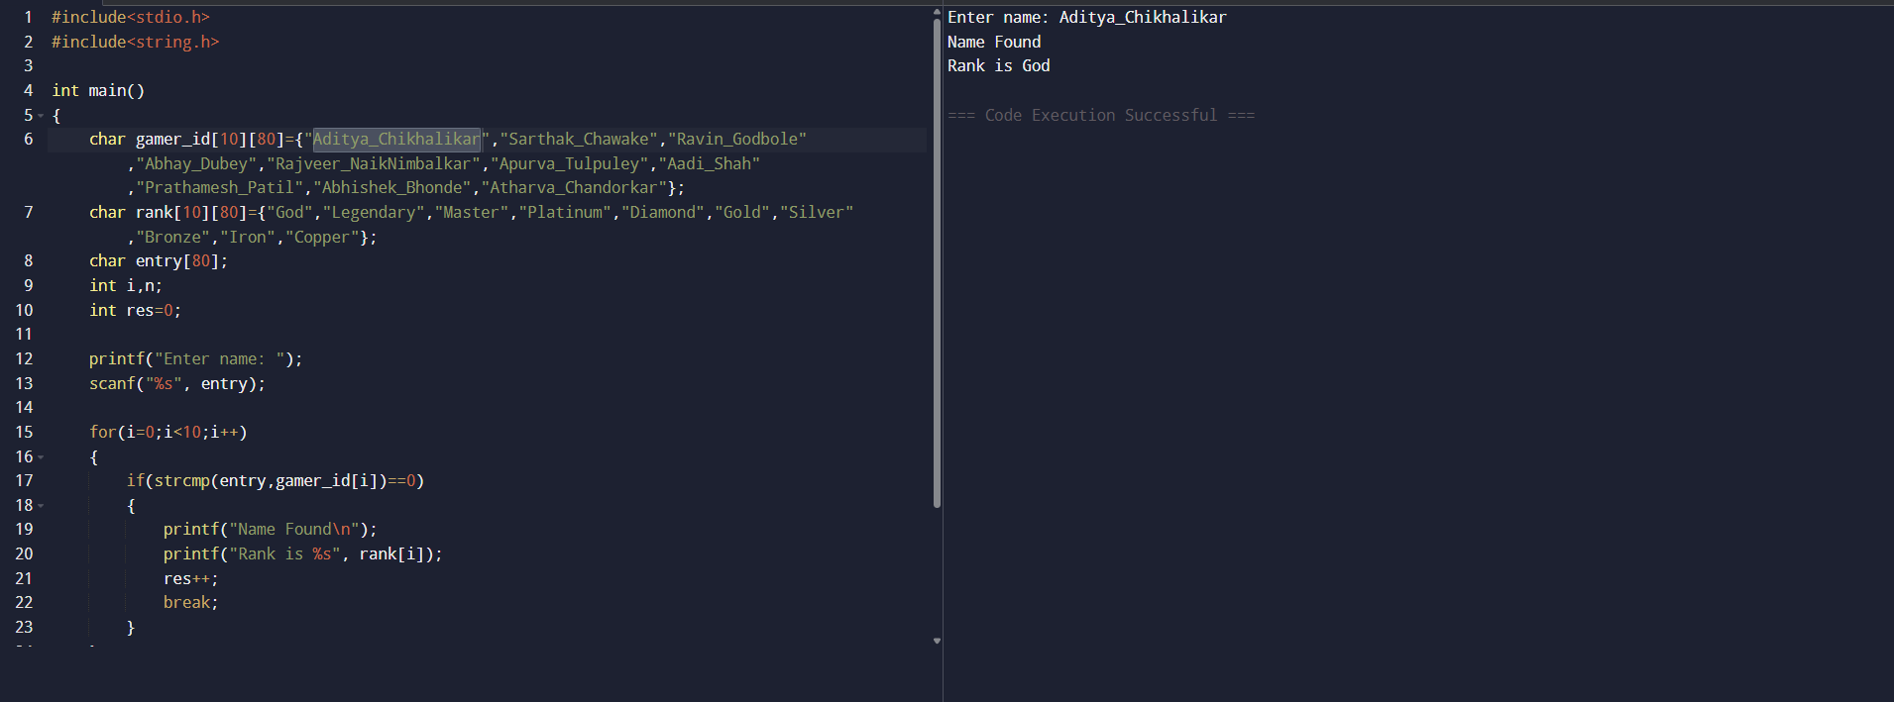
Case 2: -
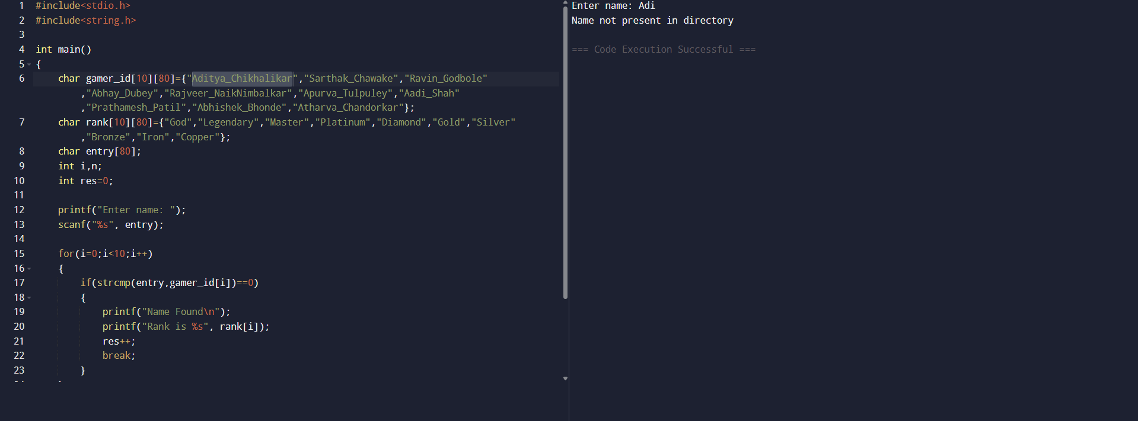

Implementation: -

Conclusion: -
Therefore, this report provides a program that gives a directory containing gamer id’s and ranks of players, thus achieving our objective.

